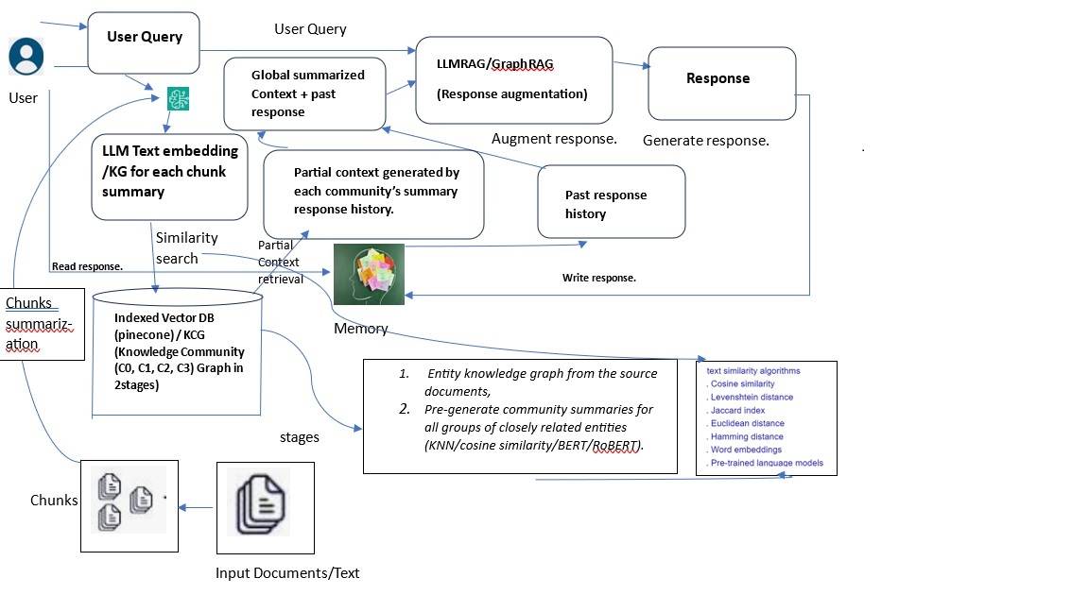
Data ingestion:
Pdf or any file format text chunk (word,sentence,semantic,proposition, llm based and summary based on user query) save chunks with metadata(mogoDB, SQLite etc.) embedding(Siamese llm)
Community wise Chunks clustering: KNN, SOM, cosine similarity on chunks embedding, summarized chunks then cluster.
Vector DB to store Embeddings: multivector approach for hybrid search, milvus, pinecone, Neo4j to improve accuracy and search space. save embeddings for similar community/clusters for docs/chuncks
RAG (Retrieval Augmented Generation)
Retrieval: similarity search with cosine similarity from all communities and generate the partial context. If no coherence context found, then agent-based retrieval approach will be used. Below the explain how agent improve to augment the response by LLM by providing coherence context from all clusters/communities.

GenAI Multi Agent based RAG to retrieve complex information:
Agent is responsible to create coherence context and optimize the overall performance of the RAG system.

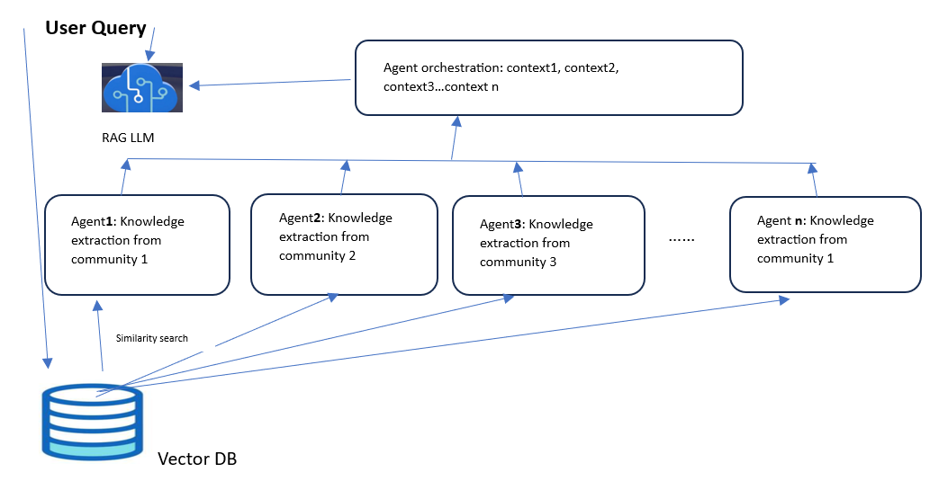
Augmentation: Giving the user query and the coherence context generated by agents’ orchestration helps LLM to augment user query’s responses.
Generation: LLM generates coherence response based on augmented response which will be me structured and accurate. That can’t be possible without agent support.

